Curriculum Vitae Arletta Boland
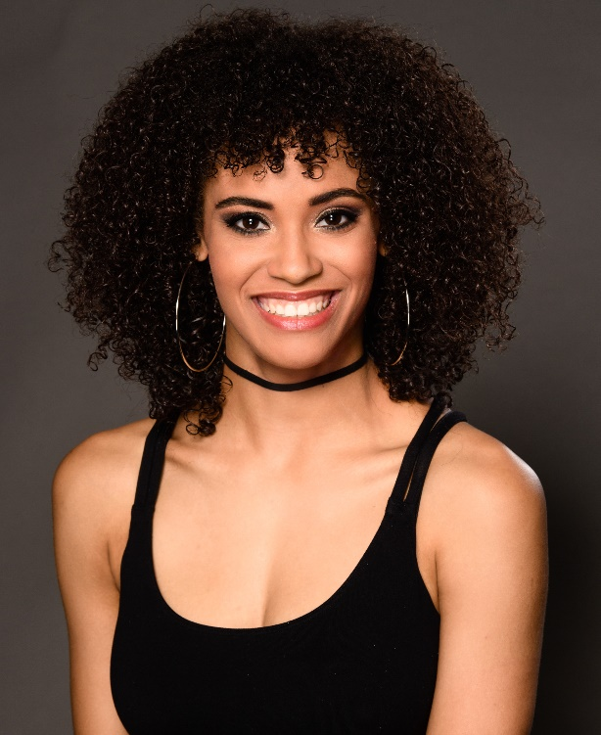
Personalia
Name : Arletta
Surname : Boland
Adress : Notarisappel 117, 4007 ZD
City : Tiel
Phone : +31 6 22 58 29 19
Email : arletta.boland@gmail.com
Date of birth : 26 – 11 – 1994
Nationality : Netherlands

Appearance
Sex : Female
Eyes : Brown
Hair : Dark brown
Skin colour : Light skinned
Length : 1.70m

Dance education
2013 – now : Urban Contemporary (Jazz Musical Dance), Bachelor of Arts,
Amsterdam School of Art
2003 – 2013 : pre-education: Lucia Marthas Institute of Performing Arts

Highschool
Graduated : Bilingual Gymnasium (2013)

Bachelor Dance performances:
2015 : Dead voices Gianni Grot – Gianni Grot Company
2014 : Instable Nicolas Sannier, S’poarts – Mickael le Mer

Performances
2016 – 2017 : The Bodyguard the musical, choreography by Kim Duddy
Ensemble and cover backing vocalist (internship)
2016 : SKY 3D musical, choreography by Keone and Mari Madrid,
Ensemble dance and cover of Army 9, Summer, Nurse 1,
Nurse 2 and Reporter (internship)
2016 : Gold by Dash Berlin & DBSTF ft. Jake Reese, Waka Flocka &
DJ Whoo Kid (dance video), choreography by all the dancers
2009 : Avro’s Televizierring, theater Carré, Amsterdam
2006 : Avro’s Televizierring, het Muziekgebouw aan het IJ, Amsterdam
: Musicals in Ahoy

Skills
Singing : vocal range D – C³, Belt to E
Genres: Pop, R’nB, Musical, Rock
Dance : Contemporary, Urban, Ballet, Modern, Hip Hop, African, Showdance, House, Jazz, partnering
Special skills : Tap

