CURRICULUM VITAE EMMA GEERTJE WIJBENGA
Personalia
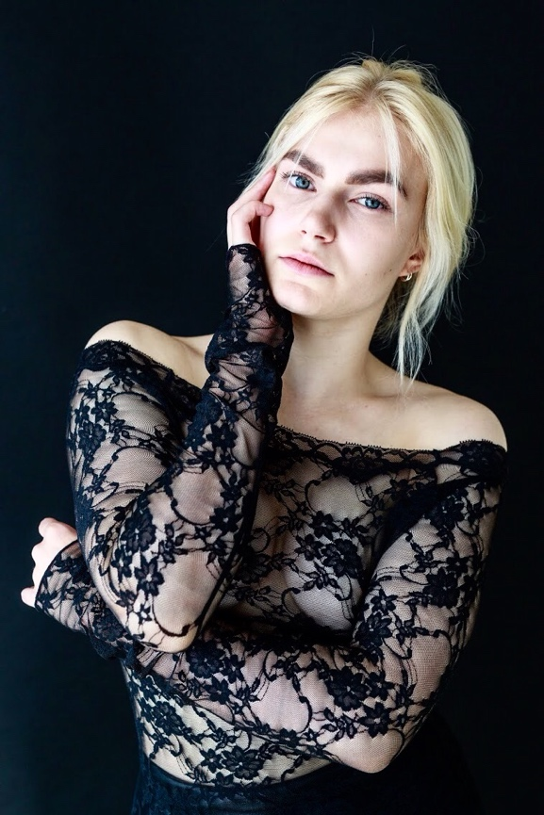
Name: Emma Geertje
Surname: Wijbenga

Adress: Dalsteindreef 4335
City: 1112 XJ Diemen
(Amsterdam)
Phone: +31 6 30415036
E-mail: emmawijbenga@gmail.com

Date of birth : 22|10|1993
Nationality: Dutch

Appearance

Sex: Female
Eyes: Grey
Hair: blonde
Skin colour: White
Height: 1.68 m

Dance Education

2012- 06/2016: Bachelor of Dance , Amsterdam School of Arts (AHK)
Artistic Director: Eddi de Bie / Gerleen Balstra

2010-2012: Lucia Marthas school of performing arts

Highschool

Graduated: Gymnasium (2012)

Experience

2016: IT’S Festival own choreography

2015-now: West Side Story Joost Vrouenraets
Theater Aachen Germany

2015 Miraculous Wednesday Club Guy&Roni

As if I was, as if we were Heidi Vierthaler

2014: Orbital Elias Lazaridis
Eastman; Sidi Larbi Cherkaoui
Political Mother Winifred Burnet-Smith & Erion Kruja
Hofesh-Shechter

CURRICULUM VITAE EMMA GEERTJE WIJBENGA
Extra Skills

Singing/use of voice
Tap dancing
Physical Theatre

Intensives/Masterclasses

Elias Lazaridis – Eastman (Sidi Larbi Cherkaoui) repetoire
Heidi Vierthaler – Stream/flow
Hofesh Shechter – repetoire
Sidi Larbi Cherkaoui - repetoire
Alain Platel; repetoire
Club Guy&Roni - repetoire
LeineRoebana -repetoire
Sara Wictorowicz – Physical Theatre
Vivian Rodrigues de Brito; Fly & Low

